St. James Catholic School

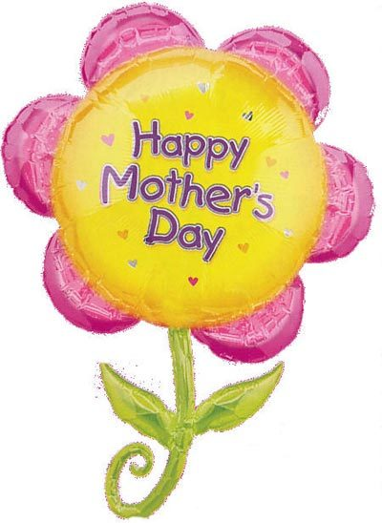

Kindergarten Newsletter May 2017

Dear Parents,

April was a busy month! Now that the weather is finally starting to warm up, **please ensure that your child comes to school wearing sunscreen and with a hat for our outdoor time.**

In Language this month, we will continue working on word families and journal writing. We will also continue making connections to stories that we read together, as well as build upon our great reading strategies. **Please remember to return the ‘Borrow-a-Book’ every Thursday**. Please also continue to review the letter names, sounds, and actions.

Our next focus in math will be estimating and composing/decomposing quantities to 10. We will then move to investigating addition and subtraction in everyday activities through the use of manipulatives. Please continue to help your child practice counting whenever possible – including ordinal numbers (1st, 2nd, 3rd, etc.).

In Science we continue to explore new life with our life cycle inquiry. We are making predictions and observations about our learning as we explore how plants and animals grow and change. As we move through the month, ask your child to share their learning about the following cycles: flower, frog, chicken, and butterfly.

Attached are the May Scholastic flyers. If you would like to order, please send your order form by Friday, May 5th. *Cheques or online payment only please!

 **Please remember to return ‘Mr. Zippy’ communication bags daily!**

We would like to wish all of our moms a wonderful Mother’s Day! Thank you for everything you do for your child!

Thank you for your continued support,

Mrs. Simpson & Sister Cristina